Working the world on VHF and UHF FM - using internet gateways

Ian Abel G3ZHI g3zhi@hotmail.com

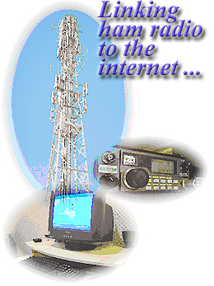
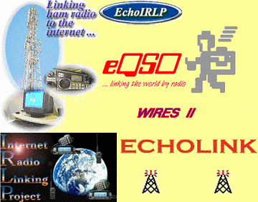

Would you like to keep in touch with your hams friends all over the world any time of the day or night?

Moved into a retirement home where HF equipment and antennas are not allowed?

Have you had to take down your tower and beam because you can no longer maintain them?

Then why not use an internet gate way to keep in touch with hams friends around the UK and the World.

Internet gateways operate on VHF and UHF simplex channels and repeaters using FM. The quality of the audio is mostly excellent and because you are using the internet and not radio there are no problems with propagation. You can just dial up your friends whenever you wish.

Background
For nearly 10 years radio amateurs have been experimenting by connecting their VHF and UHF FM radios to the internet.

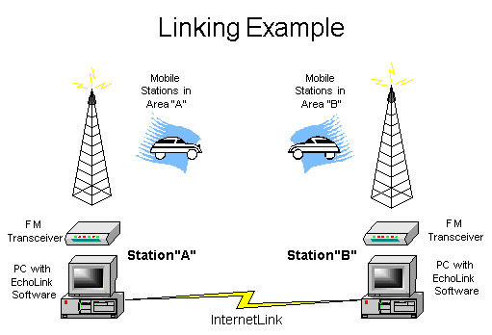
In the year 2000 after a personal request from Ian G3ZHI David Hendon G8DPQ who was the Chief Executive of the Radiocommunications Agency gave his personal permission for internet gateways to licensed in the UK.

Now there are around 4,000 ham radio internet gateways all over the world many available 24 hours a day.

Operating an internet gateway
Using an internet gateway is very easy.

There are 3 main gateway systems in use Echolink eQSO and IRLP

With Echolink and IRLP it is possible using a hand held radio with DTMF or a DTMF MIC on a base station to individually call a station via the gateway.

So for example on IRLP if you wanted to call a ham in Sydney Australia using your hand held you would press the PTT and press the DTMF key numbers 6 0 0 0 then release and listen.

You would hear a voice announcement telling you that the link was connected. You would then talk and carry on a QSO normally as you would if you were working a local station. When you have finished you press the PTT and the press DTMF 7 and then 3 which closes the link.

You will then hear another voice announcement informing you the link has been closed.

You should always listen first on a gateway frequency to see if it is in use. You can also send a ‘0’ to see if it connected to anywhere.

Recently a local ham from Doncaster Kevin G8JJR visited Perth for 8 weeks and he was able to keep in touch with his friends back home in South Yorkshire by calling from there every day using his hand held working the local repeater which is connected to the IRLP network.

Echolink and eQSO can also be used from a PC computer providing the computer has a soundcard with MIC and speakers attached.

IRLP can only be used using a radio.

If you are on the internet you can see the live status pages showing which nodes are connected on all the three systems.

Much more information is available on the web sites.

Here are some examples of the information shown .

IRLP Node Status current as of 07/9/2004 06:25:05 GMT

Network Summary
1384 - Total Nodes 86 - In Use 805 - Idle 58 - Offline

Antarctica 2
Antigua 1 Australia 71
Barbados 2 Belgium 1
Bermuda 1 Botswana 1
Canada 236 Cayman 1
Chile 1 China 1
Denmark 1 Dominica 2 1
Ecuador 1 England 57
France 1 Germany 6
Grenada 1 IRELAND 1
India 1 Jamaica 1
Japan 11 Korea, Republic of 1
Mexico 7 Netherlands 4
Netherlands Antilles 2 New Zealand 11
Norway 3 Puerto Rico 1
Saint Kitts & Nevis 1 Scotland 5
South Africa 5 Spain 1
Sweden 15 Trinidad 1 1
Trinidad and Tobago 3 USA 917

Sample IRLP Node codes and locations :

Length of current node status.
Node Callsign City Prov./St. Country NodeFreq CTCSS
3540 W6DXX Palm Springs CA USA 445.6400 131.80
3257 WA7DG Reno NV USA 147.3000
3160 WA6RQD Oceanside CA USA 446.8600 0.00
3150 WA6RQD Oceanside CA USA 449.3200 141.30
3900 K6MF San Jose CA USA 1286.4500 123.00 23:39
3671 K6SA Saratoga CA USA 146.6550 114.8 23:39
4865 KG4ZXK Portsmouth VA USA 145.6000 0.00
8310 KB5KZS Bartlesville OK USA 145.7000 88.50
8274 XE3NO Oaxaca Oaxaca Mexico 146.8800 103.5
2380 VE6RJO Calgary AB Canada 147.5100 100.00
8710 KD5KTB Enid OK USA 146.5550 97.40
7240 KB2CDY Payson AZ USA 146.4200 100.00
4490 WB2CIK West Hills NY USA 447.9500 114.80
4870 W1HHO Mid Coast ME USA 449.1250 82.50
6000 VK2RBM Sydney NSW Australia 147.0500 0.00
5450 GB3PZ Manchester England 430.9000 82.5
5400 GB3PZ Manchester - England 430.9000 82.50
4300 N3APP Erie PA USA 147.2700 141.30

Sample list of echolink nodes and locations

4Z4IZ-R HAIFA R-12 Rpt. 169676
4Z7CCF-L Tel-Aviv 432.675Mhz
7K1FHJ-L ohshima 432.34 128671
7K1NAQ-L Bunkyo,Tokyo 1294.82MHz 22778
DL9GRB-R Link to DB0DBR 159122
DM0ZAA-L Duesseldorf 144.975 MHz 136397
DM0ZBB-L Boeblingen (BB) 430.025 6877
DO0SMZ-R Mainz 439.2125 MHz 100823
DO0ZB-L Berlin 144.975 pse CQ 8222
DO0ZFG-L DO @ 144.975 Mhz 154965
DO1GUM-L Freiburg, Black Forest 129169
DO1HEN-R D B ÿ S Y - HAMBURG 153627
DO1JOH-L GER JN49MD 145,575 151037
DS5CLX-L deagu 145.540 (1) 21440
DV1LWQ-L In Conference *MAKILING* 130919
E20ZGH-L In Conference *TACLUB* 177730
EA1RCW-L FOZ 172581
EA3RCB-R Palamos 145.300 113456
EA4TD-L In Conference *ESPANA* 82308
EA5RCI-L In Conference *ESPANA* 97451
EB2CTZ-L In Conference *ESPANA* 153942
EB2FGI-L In Conference *ESPANA* 115083
EB4CKB-L In Conference *ESPANA* 24853
EB8BCG-L Tenerife 145.550 MHz (1) 56868
EB8CHG-L lanzarote pls cq 128358
F5POE-L Forges les B 91 144.525 76584
F6CDD-L Toulouse 145.250 100889
G0OPD-L South Hampshire 1515
G0WYG-L Bromley Kent,UK 434.475 3275
G3SNA-L Greenfield Lancs 2586
G3ZHI-L Maltby South Yorks 99045
G4IPE-L Louth, UK www.g4ipe.com 37980
G4LCH-L Solihull UK 136330
G6CKK-L Rochester Kent 145.2 (1) 93069

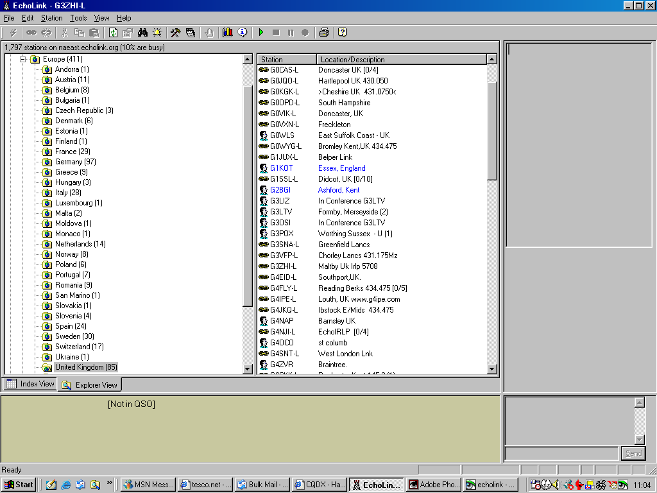
Echolink is in 200 countries and has been downloaded by 200,000 hams

Sample list of UK internet gateway frequencies and location

G4NJI | 434.5250 | Rotherham | IO93ij | 6/3/2001 09:00
G0FSM | 51.9300 | Rugeley | IO92br | 4/2/2003 17:44
G0JJO | 430.0375 | Rugeley | IO92as | 18/6/2003 17:10
G0NWE | 51.9400 | Runcorn | IO83pi | 4/2/2003 17:44
G0NWE | 430.0125 | Runcorn | IO83pi | 4/2/2003 17:45
G0LGJ | 434.5250 | Scarning, Dereham | JO02lq | 7/10/2003 12:14
G4YPV | 430.0125 | Selby | IO93lr | 7/6/2003 19:27

If you don’t have access to the internet at home there is free access at your local library where you can download and print the list of gateways and station numbers.

Helpful library staff will show you how to use the internet if you have not used it before.

If you want to set-up an RF gateway you need an NOV from Ofcom. You must hold an intermediate or advanced licence to do this.

If you have any questions please contact me g3zhi@hotmail.com
01709 799911 Mobile 0783 338 0578

More information can be found at

http://www.echolink.org
http://www.irlp.net
http://www.eqso.net
http://www.qsl.net/g3zhi
http://www.gb3dx.co.uk
http://www.ofcom.org.uk
http://www.rsgb.org
http://www.dcc.rsgb.org/ShowGates.asp?call=ALL
http://www.ukirlp.co.uk
http://www.gb3ir.co.uk
http://www.eqso.info

Ian Abel G3ZHI
52 Hollytree Ave
Maltby
Rotherham
Yorkshire
S66 8DY

G4NJI IRLP 5200 Echolink 135909
Rotherham simplex 145.2875mhz

GB3XN IRLP 5708 Echolink 153126
Langold 430.925 Mhz

Tel: 01709 799911
Mobile 0783 338 0578

